Spatial niche project – Summary

# Principal objective

Quantify to what extent tropical trees niche-differentiate by specializing to different soil resources.

# Subgoals

1. Infer and enumerate the “soil niches” in a forest.
2. Assess whether our inferred soil niches correlate with measured soil indicators (nutrient concentrations). If so, this lends credence to our inference.
3. Assess whether our inferred soil niches correlate with species traits. If so, this provides a link between species traits and the types of soil resources to which they specialize.
4. Obtain an affinity matrix to be compared with D’Andrea, Gibbs & O’Dwyer 2020 to make inferences about whether non-neutral behavior should be observed at the community level.

# Methods and Results

**Inferring and enumerating the soil niches**

1. First, we considered every pair of trees within the 50ha forest dynamics plot (FDP) on BCI and determined whether species A and B tended to occur in close proximity (i.e. d_{tree1, tree2} < d_cutoff) more than expected by chance. We used a distance cutoff of 20-30 m, as this is the estimated range of physical interaction between neighboring trees (cite literature). We also restricted the analysis to species above an abundance cutoff, because we lack statistical power to determine whether rare species are physically closer than chance.
2. We treat the FDP species as nodes in a network, with links between species that were found to be in proximity beyond chance.
3. We then use R package *igraph* to find “communities”, i.e. subsets of nodes that are unusually interconnected and relatively isolated from all other nodes in the network. This “community-finding” algorithm uses random walks to find these subsets (i.e. the notion that if you’re moving around the network randomly, you will tend to spend most of your time within the same community).
4. The community-finding algorithm reveals 3 such species groups (Fig. 1). We identify these groups as being the “soil niches” (“sniches”), i.e. the three distinctive strategies regarding soil resources. Upon finishing this part of the analysis, each species has a sniche label.
5. We can perform network-based analyses to determine how tight the classification is, and whether it is statistically significant. For example, I found that the *modularity* of this three-sniche graph is significant by randomizing the species labels of the FDP trees, finding communities among the resulting graphs, and calculating the modularity of the results.
6. John checked that this result is also robust to using different cutoffs for the interaction distance and minimum abundance. Using distance cutoff from 2 to 40 meters, abundance threshold from 0 to 400 we consistently find three clusters, with some exceptions of 2 and 4 clusters. Upon visual inspection, the predicted soil landscape looks similar over a wide range of distance (10-30 m) and minimum abundance. We ultimately use the parameters: distance = 10m, abundance cutoff = 50 for the following analysis.

**Assessing whether our niches correlate with nutrient concentrations in the FDP**

1. Each of the 3 niches corresponds to a bias for preferentially recruiting in sites whose local soil conditions match the sniche. In other words, we infer from the finding of three sniches that the FDP has three ecologically relevant “soil types”, which are presumably a composite function of all the conditions that matter for plant recruitment (nutrients, water, pH, toxicity).
2. Given the coordinates of each tree in the FDP and the sniche labels resulting from our graph analysis, we can infer the soil type under each tree via *kernel density estimation:* we suppose continuity/autocorrelation in the spatial distribution of soil types, and in particular we assume that if a point (x0, y0) has soil type 1, then points (x, y) separated by distance d have probability P_1(d) of belonging to soil type 1 and 1-P of belonging to one of the other soil types. Doing this for every data point returns a map of probabilities for the entire FDP. (John performed this analysis).
3. At this point we have options for what to do next. The simplest is to assign each pixel the soil type with the highest probability. A more complicated alternative is to instead work with the probabilities. I chose the simple route (Fig 2).
4. We have publicly available data (from R. John, Dalling, et al PNAS 2007) on the concentrations of several nutrients on BCI (namely P, B, K, Mg, Mn, Cu, Ca, pH, organic N, mineralized N, and Al) at the scale of 20m-by-20m quadrats spanning the whole FDP (1,250 such quadrats). We can then compare the raster of soil types with the raster of nutrient concentrations, looking for a correspondence. We expect such correspondence if our inferred soil types relate to biologically meaningful features of the environment.
5. One problem we run into with this question is that both the soiltype raster and the nutrient raster are autocorrelated (in part because autocorrelation is assumed in the productions of both rasters, and then used to extrapolate from discrete datapoints). The problem is that two autocorrelated rasters may match better than chance (here meaning expected matches between the cells of permutated versions of said rasters) simply because both rasters tend to be blobby: it is easier to match blobs than to match small cells. One solution to this problem is to compare the match not against fully randomized rasters, but against *partially randomized* rasters, where we permutate cells within a certain distance scale but keep the overall shape of the blobs (see Fig. 3). We then compare the match level against null models randomized at increasingly large distances.
6. Another thing to consider is that most of the nutrient concentrations are highly correlated: basically, the right side of the FDP is high in nutrients except P and organic N, the left side is low in nutrients and high in Al (which is toxic to plants), and the middle has the most P and organic N (Fig. 4). This suggests that we can simplify the analysis by running a *PCA* on it. Indeed, the 1st and 2nd principal components account for 93% of the variance in nutrient concentration. This is also obvious from plots of the cells on the PCA plane colored by nutrient concentration. The high and low nutrient areas are well separated on the PCA plane – as are the soil types! (Figs. 5, 6) This suggests very strongly that our inferred soil types are meaningfully connected to soil nutrients. Specifically, it is clear that soil type 1 (red) corresponds to alkaline soils with high N and P, soil type 2 (green) corresponds to low nutrients and high Al, and soil type 3 (blue) corresponds to high nutrients.
7. One interesting way to quantify this association is to train a machine-learning classifier on some of the nutrient data and use it to predict the soil types of unseen data. I used the *C5.0 decision tree / rule learner* algorithm to do this, and results are very good. Using repeated 10-fold cross-validation, I find that the soil nutrients predict the soil type with high accuracy (> 85%). To measure the quality of the prediction, I used *Cohen’s Kappa*, which is a measure of how the observed accuracy exceeds predicted accuracy (i.e. the proportion of correct guesses achieved by guessing at random). This index varies from 0 to 1, with values between 0.6-0.8 considered good agreement and > 0.8 considered very good agreement. For our data, I am finding Kappa ~ 0.83.
8. By comparison, when we train the AI on partially randomized nutrient data at different scales, we see increasingly poor predictions (Fig. 7) I think the fact that the better-than-chance agreement doesn’t just collapse to zero indicates that spatial autocorrelation in both the nutrient and soiltype data plays a role. However, the fact that we see a large drop in predictive power when randomizing at scales smaller than the blob sizes indicates that our results are not solely due to this autocorrelation.
9. John also trained a neuro net on the same data, and found that … (John, please fill in here).
10. Overall, these results are at once reassuring and exciting. They’re exciting because we were able to predict high- and low-nutrient areas in the FDP indirectly via patterns of spatial proximity between species. It is reassuring because from the outset the project is founded on the idea that these patterns are created precisely because of soil heterogeneity, so it’s good that we are confirming that assumption post-facto.

Assessing whether our soil types are associated with species traits.

1. The results above are cool but expected. In fact if we didn’t find a correspondence, we should be concerned. However, it would be very exciting to find that our soil types predict species traits or vice versa, because then we’d be connecting traits to niches – which I’m all about!
2. We have trait data that Joe Wright at STRI shared with me for the BCI trait clustering project. First, I trim the data down to five trait categories: *vital rates* (dbh growth, mortality), *size traits* (dbh, height), *leaf traits* (all sorts of leaf density), *seed traits* (fruit and seed size), and *wood traits* (dry wood density). Then, I run a separate PCA on each of these categories, keeping the 1st principal component. This leaves us with 5 trait-based features on which to train the AI to predict the sniche of the species. (Note: unlike the nutrient data, the trait data has *a lot* of NAs. We’re forced to use value imputation methods to deal with those NAs, otherwise we’d lose a lot of the 77 species in our analysis). I perform this category-specific PCA analysis for several reasons:
   1. We argue in our Translucent Windows paper that measured traits are imperfect proxies to the actual niche axes, and collating information from several related by different measures could yield better results as it could reduce the measurement noise. So instead of using 17 different leaf traits as predictors of the sniche, we collapse all these measures into a single axis of leaf longevity/sturdiness.
   2. Most of the traits are strongly correlated (Fig. 8)
   3. Correspondingly, reducing the covariate tally from over 20 to the 5 first components for each trait category greatly improves the AI predictions from Kappa = 0.2 to Kappa = 0.5.
3. Results here are weaker than with nutrients, but still definitely significant. The C5.0 rule learner returns a Kappa of about 0.5, which is considered moderate agreement. With randomized data you get Kappa = 0 (Fig. 9). One advantage of the C5.0 algorithm over neuro nets (which are more powerful and often more accurate) is interpretability of results: we get a set of rules such as *If mortality is below X and leaf density is above Y, then classify the species as sniche 1*. (See Rules page after figures) Indeed, the results I’m getting suggest that sniches 1 and 2 differ mostly by vital rates, in that sniche 1 is the slow-and-steady strategy while sniche 2 is the live-fast-die-young strategy. Sniche 3 is a bit more subtle, with similar vital rates as sniche 1 but lower leaf density and higher seed size. (Fig. 10)
4. One big achievement of this analysis would be to connect it to the nutrient analysis in a way that makes sense. So it would be great if we found that the slow-and-steady plants tend to occur in low-nutrient soils and vice-versa. However, we are finding the opposite! It looks like the slow-and-steady group occurs in the high-N high-P area, while the live-fast group occurs in low-nutrient areas, and group 3 occurs in the high-nutrient area. I can’t say I understand this. Would be interesting to hear Jim Dalling’s or Joe Wright’s opinion.

**The affinity matrix – putting our results in the context of D’Andrea et al PCB 2020**

1. Assuming the above results indicate that we are finding meaningful niches on BCI, and treating each putative soil type as a resource, we can then put together a 77 x 3 affinity matrix Cij quantifying the degree of preference of each species for each soil type.
2. I estimate Cij as the proportion of trees of species i found in sites with soil type j, relative to the total abundance of species i. This gives the matrix plotted in Fig. 11
3. In D’Andrea et al PCB 2020 we considered two consumer-resource scenarios: *specialists*, where each species has its preferred resource which it uses with proportion Cd (d for diagonal), and all non-preferred resources are used with proportion Co; and *generalists*, where the Cij is a uniform random matrix. In the first case, the degree of niche differentiation was measured as Cd / Co, and in the second, as the CV of the matrix.
4. Assuming the specialist case is more relevant here, I estimated Cd and Co by averaging over either same-niche or across-niche entries of the Cij (i.e. entries where the species is found in its preferred soil types vs non-preferred soil types). I get Cd = 0.5 and Co = 0.25, giving a ratio of 2 which is much smaller than the minimum required for non-neutral behavior to emerge at the community level. (Fig. 2E in that paper). I will note that we looked at 50 species and mean abundance = 100 trees/species in the paper, whereas here we have 77 species and mean abundance 230, which I think are comparable situations. If we believe both this estimation and the results in our PCB paper, we’d conclude that the PCB paper would predict neutral-like behavior on BCI based on our estimated Cd and Co, which is indeed the case.

# Next steps

I think the results reported above make for a publishable paper. I would be very interested to hear James’s feedback, and eventually once we’re more confident about the actuality of these results, run them by Joe Wright and Jim Dalling.

Re novelty of our paper, I think the finding of exactly 3 soil-based niches is new, and so is the association to traits. Dalling has looked at whether edaphic measures are correlated with spatial distribution of trees on BCI, but as far as I can tell not to this degree of detail of associating specific species to specific soil conditions. Methodologically, I don’t recall seeing papers that use graph-based methods or machine learning to find and describe niches.

Two things that can help us sell the paper are:

1. Tighten the story connecting traits to nutrients. Why are we finding that fast growers occur in depauperate areas and vice-versa, rather than the reverse?
2. Try venturing out to other forests. John et al 2007 discussed edaphic data not only on BCI but also other neotropical forests. If we can find trait data for those, and ended up finding consistent results, I think this could be a PNAS paper.

# Figures

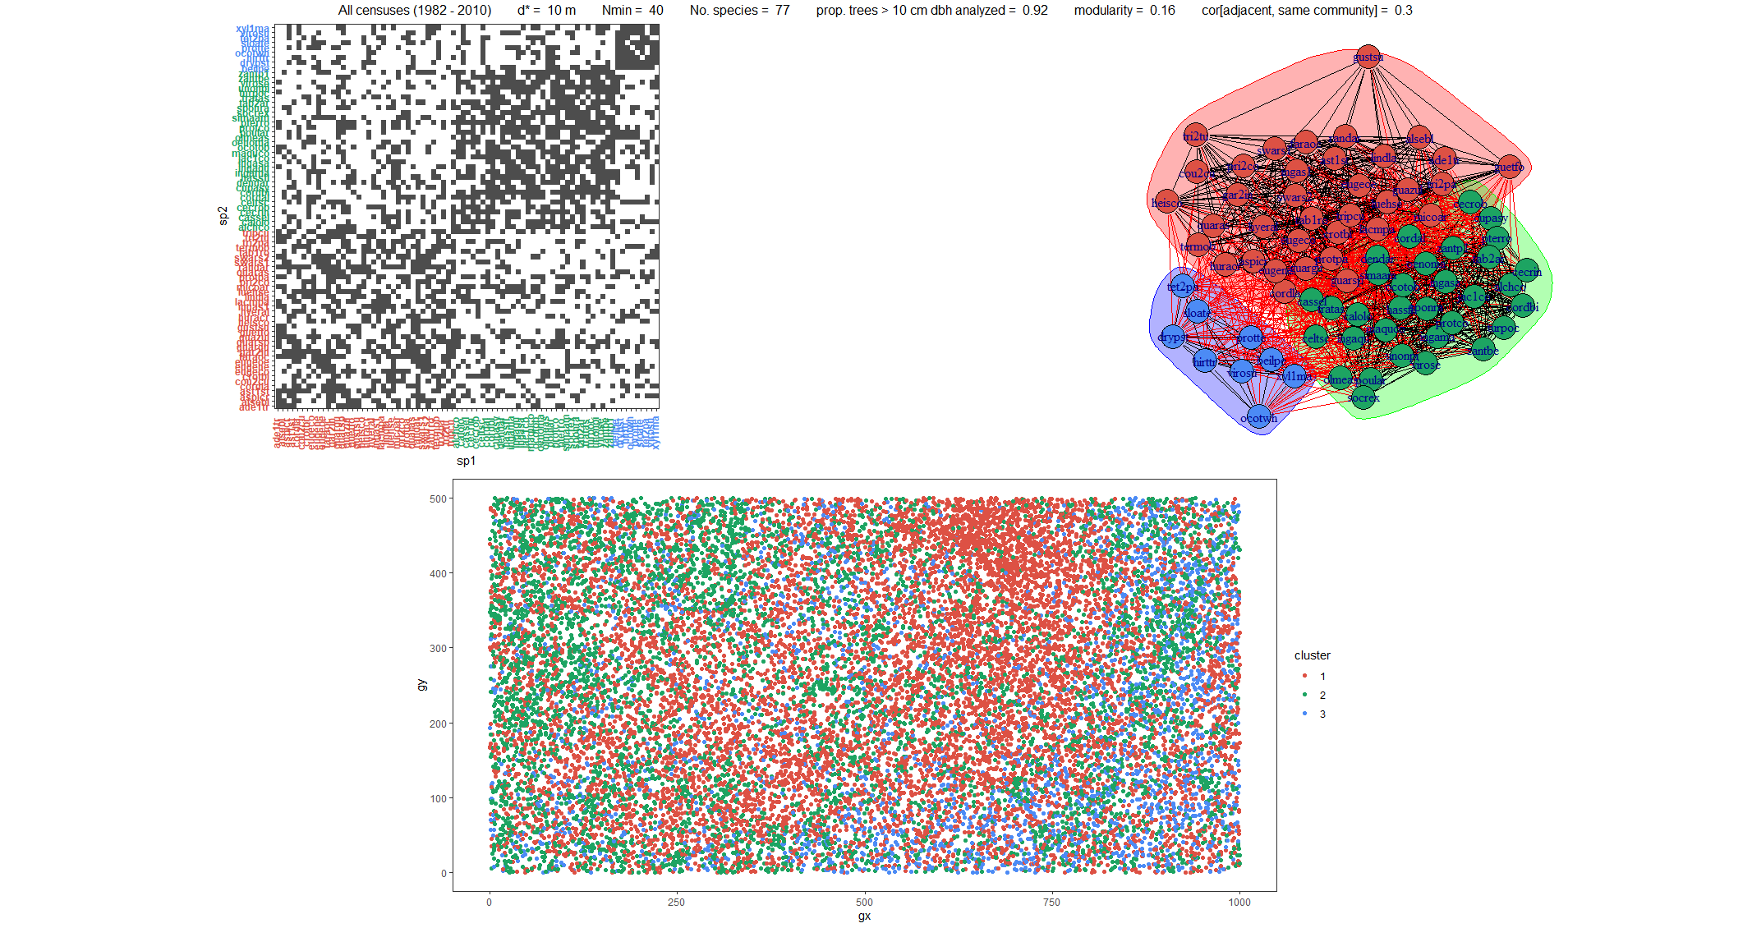

Figure 1. Top left: BCI FDP species organized by sniche. Dark pixels indicate the species pair appears in close proximity more often than chance. Top right: same information represented as a graph, with the sniches represented as colored blobs. Bottom: geographic distribution of the FDP species, colored by sniche.

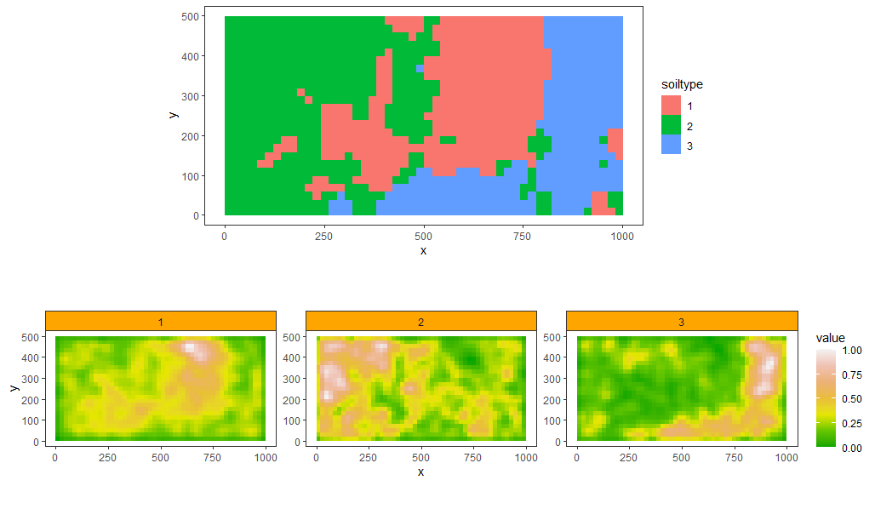

Figure 2. Top: Raster showing areas with each of the three soil types. Bottom: Rasters showing estimated local probability of each soil type across the FDP.

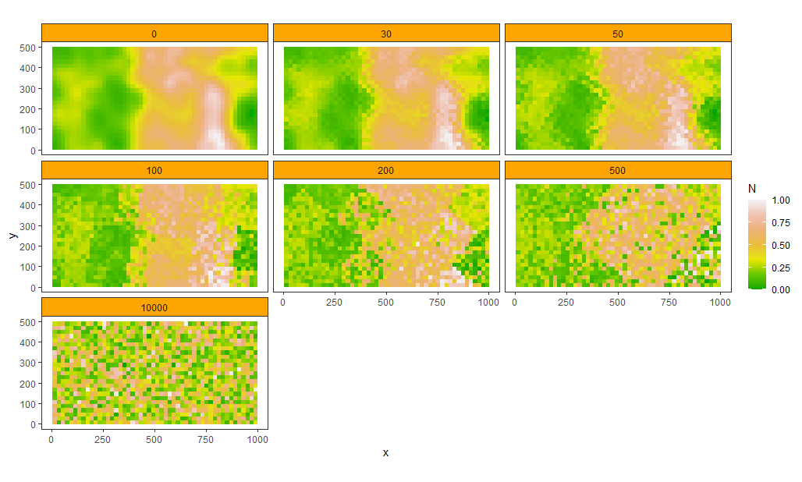

Figure 3. Illustration of the partial randomization process used to create null data to train the C5.0 classifier. Panels show different scales of randomization, such that the spatial autocorrelation is maintained at greater distances than that scale.

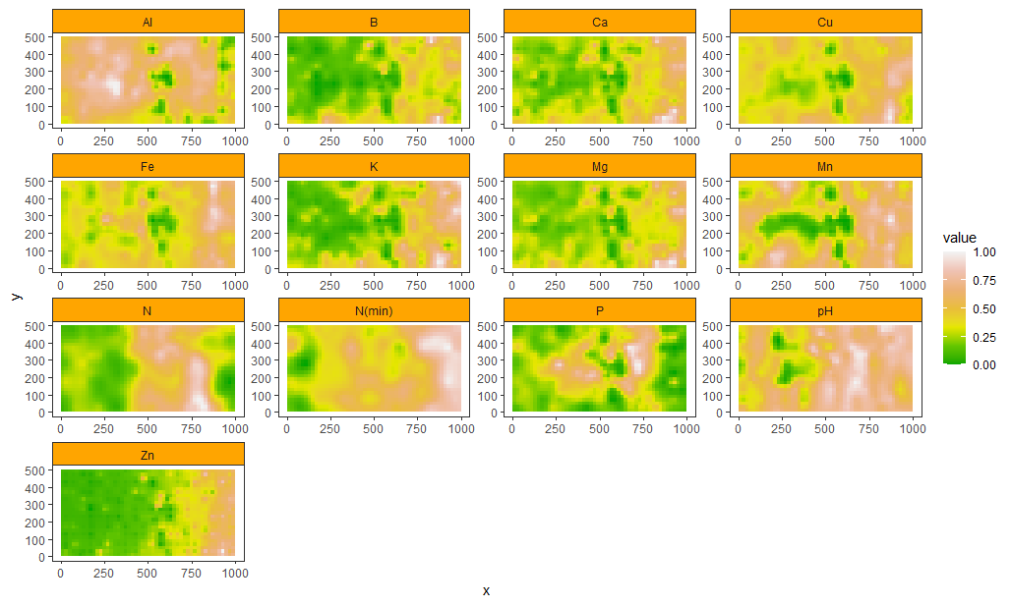

Figure 4. Rasters showing spatial distribution of each nutrient on the FDP.

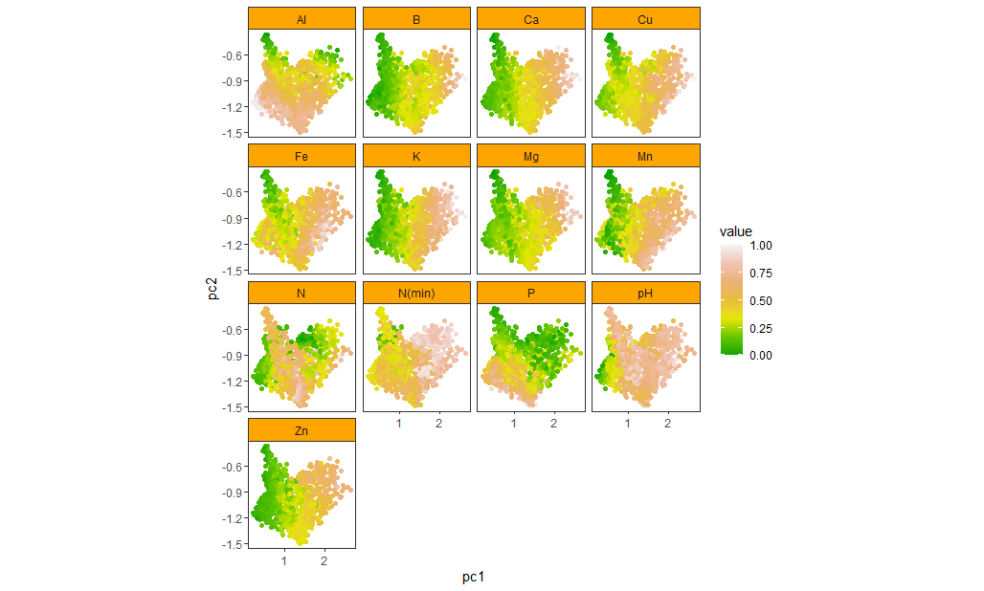

Figure 5. Representation of the nutrient concentration by the first two principal components. Each point represents a 20mx20m quadrat, colored by the local nutrient concentration. We see a clear separation between areas of the plot, and also substantial correlation between concentrations of different nutrients.

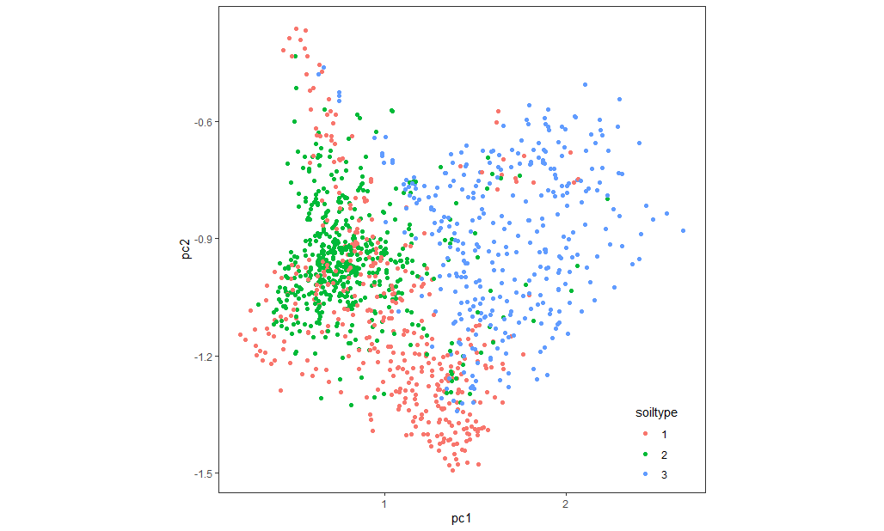

Figure 6. Same as Fig. 5, but with colors representing the quadrats’ respective soil type as per Fig. 2 (top). We see a clear link to nutrient concentration. Soiltype 1 is associated with high organic N and P, soiltype 2 with low nutrient areas, and soiltype 3 with high nutrient areas.

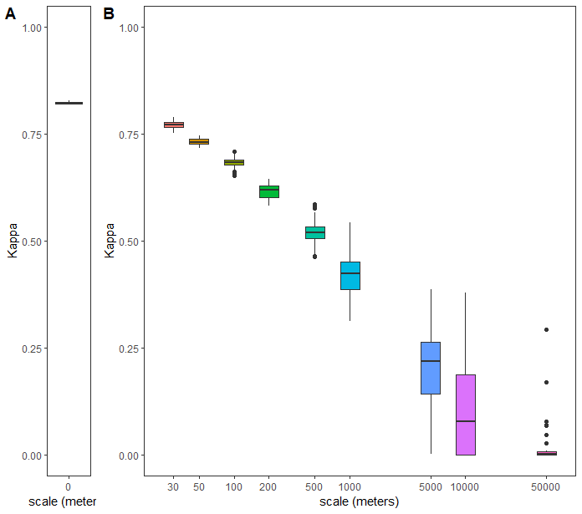

Figure 7. Cohen’s Kappa, which indicates the degree to which the classifier correctly predicts the soiltype of a quadrat, is much higher than its null expectation of 0. Kappa decreases as we train the classifier on partially randomized nutrient concentrations, with the decline being stronger at larger scales of randomization.

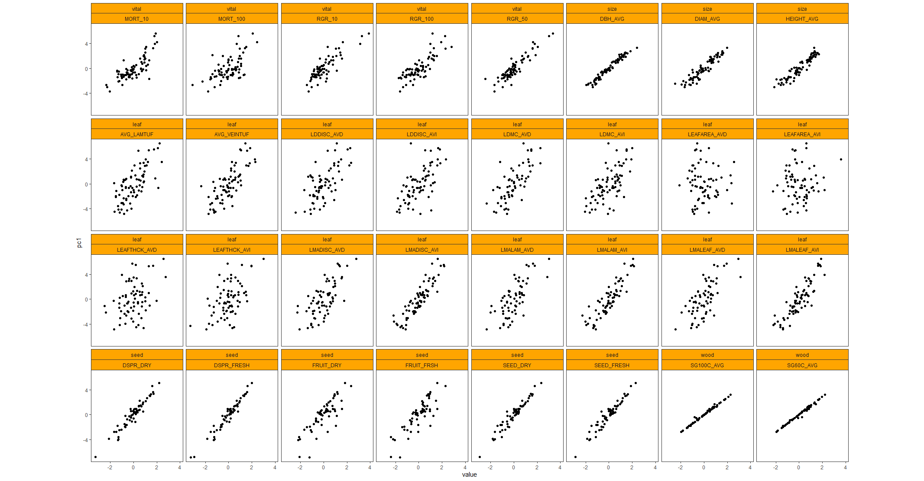

Figure 8. Correlation between the trait values and the first principal component of each trait category (vital rate, size trait, leaf trait, seed trait, wood trait). All traits correlate very strongly to its 1st component, indicating both that these traits are redundant and that PC1 is a good summary of the information contained in these trait measurements.

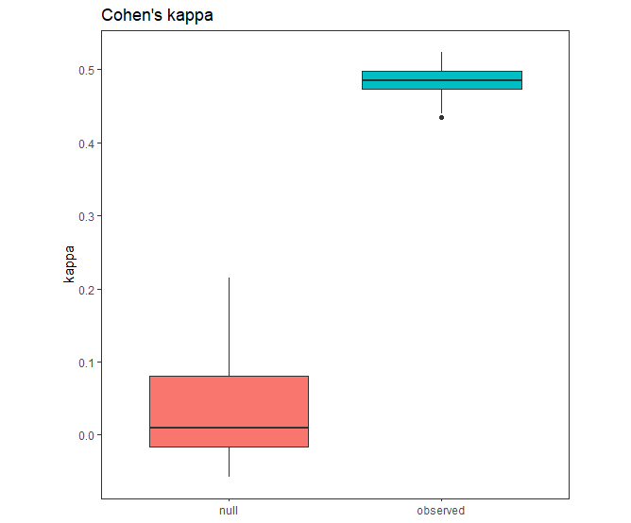

Figure 9. Cohen’s Kappa of the classifier predictions for observed trait data (blue boc) versus randomized trait data (red box). Distributions show 100 iterations of the classifier.

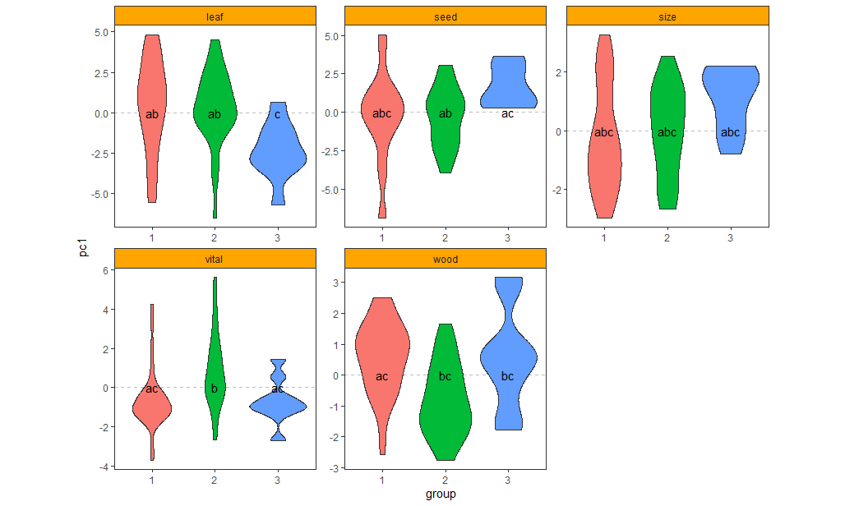

Figure 10. Trait distribution of each sniche according to each trait type.

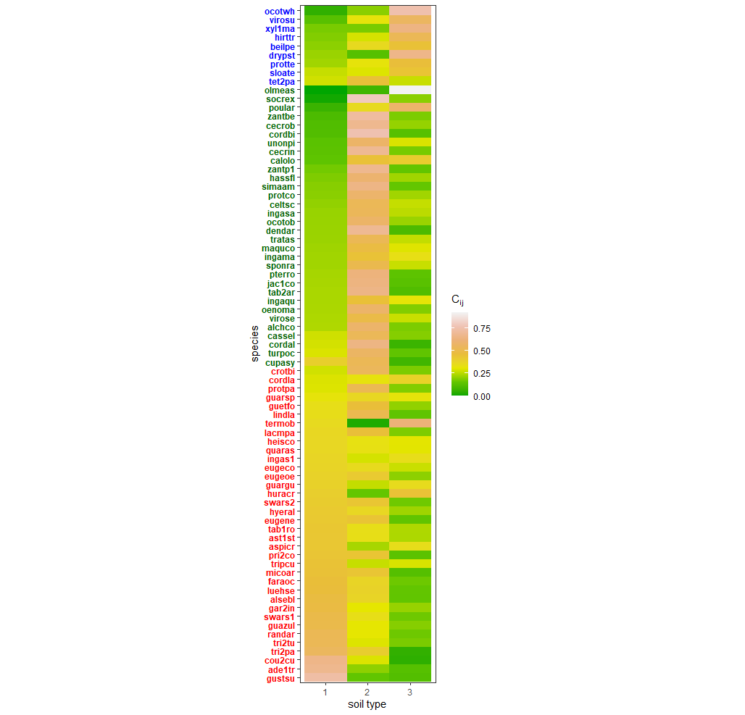

Figure 11. Affinity matrix reflecting how often each species occurs on each inferred soil type. Species codes are colored by sniche.

Rules:

Rule 1: (10, lift 2.0)

vital <= -0.3237651

leaf > -0.8982342

seed <= 0.1063058

-> class 1 [0.917]

Rule 2: (5, lift 1.8)

vital <= -0.3237651

size > 2.213931

-> class 1 [0.857]

Rule 3: (4, lift 1.8)

vital > -0.3237651

wood > 0.8139341

-> class 1 [0.833]

Rule 4: (26/7, lift 1.5)

vital <= -0.3237651

size <= -0.1007147

-> class 1 [0.714]

Rule 5: (3, lift 1.9)

leaf > -0.8982342

seed > 0.1063058

seed <= 0.4120565

-> class 2 [0.800]

Rule 6: (36/10, lift 1.7)

vital > -0.3237651

-> class 2 [0.711]

Rule 7: (6, lift 7.5)

vital <= -0.3237651

leaf <= -0.8982342

size > -0.1007147

size <= 2.213931

-> class 3 [0.875]

Default class: 1

Evaluation on training data (77 cases):

Rules   
 ----------------  
 No Errors  
 7 10(13.0%)

(a) (b) (c) <-classified as

---- ---- ----

32 4 (a): class 1

3 29 (b): class 2

1 2 6 (c): class 3

Attribute usage:

98.70% vital

48.05% size

24.68% leaf

16.88% seed

5.19% wood